**Objective**: At the end of this lab session you will learn about Nested Queries where Sub queries return only one value.

**Nested Query Part 1**

Section 1

Nested Query is a query within another SQL query and embedded within the WHERE/HAVING clause. A subquery is used to return data that will be used in the main query as a condition to further restrict the data to be retrieved.

Syntax:

SELECT column_name [,column_name]

FROM table1 [, table2 ]

WHERE [join condition AND] column_name OPERATOR (SELECT column_name [, column_name ]

FROM table1 [, table2]

[WHERE]);

NOTE: So, if you writing the subquery you must use parenthesis, and also normally we place the subqueries on the right side of the comparison condition.

If Sub Query returns one value, we can use the following operators.

|  |  |
| --- | --- |
| Operator | Meaning |
| = | Equal |
| > | Greater than |
| < | Less than |
| >= | Greater than or equal |
| <= | Less than or equal |
| <> | Not equal |

Section 2

Example Question:

Display Student names Where Student Course ID is the same as student ‘Sampath’.

Student Table

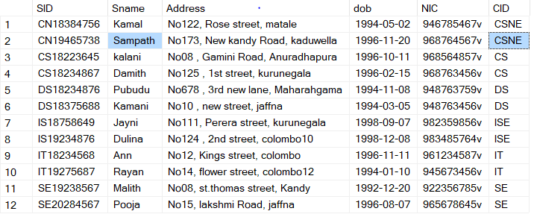

Display Student names Where Student Course ID is the same as student ‘Sampath’.

So, first, we need to write the subquery to find the Course ID of Sampath

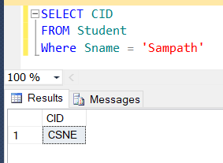

So, the course ID is CSNE So this query will be the subquery.

Then, we have to write the main Query and equal it to the subquery because we need to get the same Course ID as Sampath it means we need to find other students who do the course module ‘CSNE’.

SELECT Sname

FROM Student

WHERE CID = (<Sub Query>)

So, the Final query is,

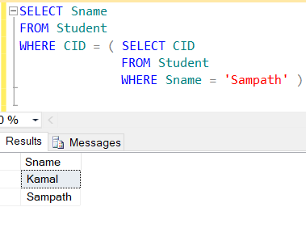

So, Kamal and Sampath are the students who do the CSNE course.

Exercise

1. What are the Module names of the modules, Where number of credits same as module code ‘IE3051’?
2. What is the name of the course with the highest registration fee?
3. What are the other modules which have lesser number credits than the ‘Fundamental of Data Mining’ module?
4. What is the name of the course which has a higher number of credits?
5. What are the courses which offer modules for year 4 students, greater than the Software Engineering course?